Checklist
Interface/HUD [A01]
Skin
Portrait/Vitals
Menus

Character Creation [B01]
Create/Load/Delete
Customize Appearance
Choose Clan and Starting Village
Character [C01]
Progression
Stats
Status Effects
Talents
Inventory/Equipment
Reputation
Rank
Genin
Chuunin
Jounin
Anbu
Basic Combat/Controls [D01]
Controls
Melee (Punch/Kick/Throw/Block)
Jutsu [E01]
Learning Jutsu
Leveling Jutsu
Common
Elemental
Clans [F01]
Aburame
Akimichi
Hyuuga
Inuzuka
Nara
Uchiha
Haku
Kaguya
Puppet
Sand Manipulator
Other
Specializations [F02]
Medical Ninja
Genjutsu Ninja
Fuuinjutsu Ninja
Clone Ninja
Sword Ninja
Weapons Master
Archer Ninja

Villages/World [G01]
Introduction/Tutorial
Shops/Loot
General Missions
Side Missions
Friendly/Warring Villages
Village Bounties
Evironment/Ambience
Day/Night cycle
Civilian NPC's

Organizations [H01]
Squads
Guilds

Additional Content [I01]
War, PVP game Modes
Assault, Cooperative game mode
Sanctioned PVP Arena

GM Control Panel [J01]
Interface/HUD [A01]

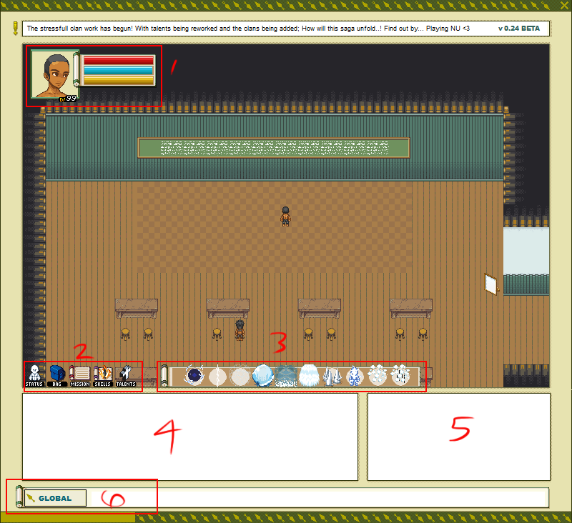

- Player's vital information and portrait.
- Menu icons for Status, Inventory, Mission list, Jutsu/Skills, and GM Control Panel if available.
- Shortcut bar.
- Chat Output
- Combat output and notifications (Without damage dealt/recieved)
- Chat input and chat channel selection (Local, Global, Squad, Guild, Whisper).
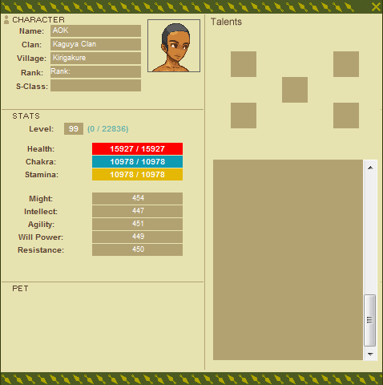
Status window. Character information on the left, Talent slots and list of available talents on the right.

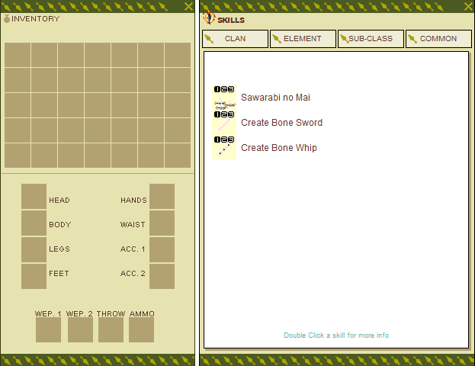
Character Creation [B01]

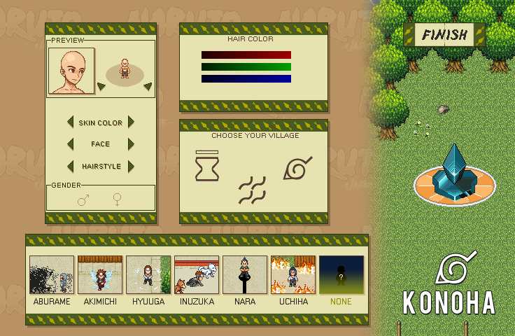
Village image on the right changes depending on which village icon is clicked. Available clans appear at the bottom, with the selected clan highlighted. Players who pick None are given another window to make their customization selections.

Character [C01]

Players progress through accumulating varying amounts experience points in different ways and leveling up. These methods should include (From least gain to greatest):

- Dealing damage
- Healing damage (Actively, not through resting)
- Defeating enemies (Player or NPC)
- Mission/Side mission completion rewards.

Vitals:


Health (Red Bar) – At 0 health, players are considered “K.O.'d” and remain on the ground until they respawn at the nearest safe hospital by pressing spacebar, or wait for another player to come and revive them.

Chakra (Blue Bar) – Basically MP, but is considered kind of a 'life force'. Ninjutsu and Genjutsu cost certain amounts of chakra to use, and reaching 0 also results in a K.O.

Stamina (Yellow Bar) – Stamina is drained when Taijutsu skills are used, or when you're running. Additionally, when players' stamina is low, their movement speed is reduced. When completely depleted, their movement speed and physical damage is greatly reduced.

The above regenerates slowly over time. This speed is increased while resting.

Experience Points (White Bar) – As experience is gained, the white bar should indicate how close the player is to gaining a level.

Stats:
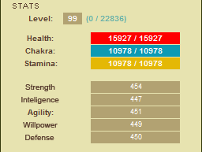

Players have 5 stats that contribute to different aspects of their character. Stats increase each level, and depending on the clan they pick, 2 of these stats will grow faster than the others. Stats can also be increased through bonuses on equipped items.

Strength – Contributes to the strength of melee/physical damage.

Intelligence – Contributes to Ninjutsu damage/defense, and increases maximum chakra.

Dexterity – Contributes to ranged weapon damage and critical hit rate.

Willpower – Contributes to Genjutsu effectiveness/defense.

Defense – Contributes to physical damage defense, effectiveness of blocking, and max health.

Talents

Talents are added advantages players can apply to their characters. They range from slight movement speed increases, to damage modifiers and added effects to skills.

i.e. “Unstoppable Force” - Grants additional 10% chance to knock back target with punches.

Talents should each be given 'value' (Or talent points) ranging from 1-5 depending on how powerful the advantage it gives you is. The maximum value allowed per character should be five, meaning you could have five active talents with a value of one, or one with a value of five, one 'three' and a 'two', etc.

i.e. Having “Unstoppable Force” active costs 3 talent points, making two points left for two talents that cost 1, or one talent that costs 2. Deactivating “Unstoppable Force” brings the available points back to five.

There are many ways to earn talents. Whether they be through reaching a certain level, completing specific missions, earned through challenges, or attatched to trophies.

Inventory/Equipment

Players are given 35 slots for loose items in their 'bag', and 11 catagorized slots for equiped items. Some items (Like throwables) stack on eachother. Players drag and drop equpippables from their bag into these slots. Changes to upper body equipment that should show up on the character portrait should be updated, if any. Dragging and dropping items onto the game world will drop the item under the player.

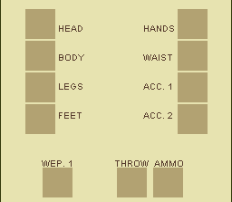
Head – Headgear equipment (Changes portrait)
Body – Equipment on the torso (shirts, armor, etc, Changes portrait)
Legs – Pants, etc.
Feet – Shoes, sandals, etc.
Hands – Gloves, etc.
Waist – Belts, sheaths, etc.
Acc.1,2 – Accessories, or extra wearables. May show up on any part of the body (May affect portrait).
Wep. - Primary weapon.
Throw – Thrown weapons
Ammo – Ammo for possible bow/arrow situation (Bow in Wep., arrows in ammo).

Reputation

Players' characters are capable of earning a positive and negative reputation in the form of reputation points. When a character is first made, they start at 0. Reputation points are earned by completing missions, and killing enemy NPC's and players. It is possible to lose reputation points by killing players and NPC's from your own village.

Dropping into negative reputation will negatively affect the way friendly NPC's respond to you (Overcharging at shops, etc), and in extreme cases can put you on a bounty list, making it safe for people of your own village to attack you without penalty. Positive reputation will change the way friendly NPC's react to you positively (Discounts at shops, etc), and may be a requirement for some ranks.

As a player advances through positive or negative reputation; they'll be able to choose a nickname that best suits their character. NPC/A.I. Will then address them as such.

Example: Tim of dual blades.
Amon of the shadows.

Ranks

Ninja are ranked within their villages, beginning with Academy Student. As they progress up the ranks, they are allowed access to higher risk missions and other privileges.

Genin | A kind of beginner ninja. Only allowed access to D and C ranked missions. Available after passing an exam early in the game.
Chuunin | “Intermediate” ninja available after passing chuunin exam trials around level 40. Access to D, C and B ranked missions.
Jounin | High level ninja available after passing a test around level 60. Access to all missions + Jounin missions. Cannot become ANBU
ANBU | Sort of a “Black Ops” group within each village. Available after passing a test around level 60. Access to all missions + ANBU missions. Cannot become Jounin.

Basic Combat and Controls [D01]

A – Block (When held) | Arrow keys/Numpad - Movement
S – Punch (Alternate between Left and Right hand punch animations)  IF MAIN WEAPON EQUIPPED, attack with that weapon. | 1-0 – Activates skill in corresponding shortcut slot
D – Kick (Alternate between High and Low kick animations) | Click Mob – Target mob
F – Throw equipped throwing weapon. | Tab – Targets nearest targetable mob.
E – Rest | Q – Deselect targeted mob
Z – Clone swap

Punching – Damage dependant on Strength. Very brief delay between punches. Small chance to knock enemy back a couple tiles.

Kicking – Strength dependant, slightly more powerful than punching. Brief delay between kicks. Small chance to knock enemy back a couple tiles.

Should be possible to punch and kick in tandem.

Blocking – Holding 'A' will put a character in the blocking state. In this state, they will be rooted in place, and the damage they take from the direction they're facing should be reduced. They will also be able to change the direction they're facing without moving tiles by using the arrow keys.

Throwing – Only available when a throwing weapon is equipped. There are 4 primary throwing weapon types. Each one travels a max distance of 14 tiles when uninterrupted. Each have varying damage severity and require you have the appropriate amount of that specific weapon equipped (i.e. Cannot throw needles if you have less than 5).

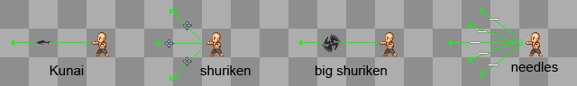
Kunai (Throwing Knife)/  Chakra Knife | Single projectile straight ahead. Moderate damage.
Shuriken (Throwing Star) | 3 projectiles spread. Light damage per projectile.
Big Shuriken | Single projectile straight ahead. High damage.
Needles | 5 projectiles spread. Light damage per projectile.

Rest - Switches to resting state. Increases regeneration speed of vitals.

Targeting – Some jutsu will require the player to have the person they want to attack targeted. These jutsu generally home in on or attack the target directly.

Jutsu/Skills [E01]

Jutsu (Or skills) come in 4 different catagories.

Common | Basic pool of jutsu/skills available to everyone.
Elemental | Jutsu based in one of the five elements.
Clan | Specific jutsu based on and restricted to the clan (class) the player picks.
Specialization (Sub Class) | Additional skills based on the player's chosen specialization (Swordsman, Illusion, etc).

When players begin, they start with their basic Common and Clan jutsu. Early in the game (Introduction/Tutorial), most players will be given their first opportunity to pick one of the five element skill pools to use. Later, they will be able to pick one more. Though there are some clans that must have a specific element. Additionally, at a certain point, players will be able to take on one Specialization (Or sub class) which offers another unique jutsu pool.

Leveling Jutsu

Each individual jutsu has up to 3 levels of proficiency. 1 being the starter “novice”, or least effective, 2 being intermediate, and 3 considered “mastered”. As the level increases, the jutsu evolves and may do things like deal more damage, become more effective, gain added effects, increase in range/coverage, and/or fire additional projectiles. In some cases the appearance changes.

Jutsu are leveled individually over time through:

- Use
- “Challenges” attatched to a specific jutsu sets. Completing these challenges will substantialy help with leveling a jutsu.

Learning Jutsu

The jutsu are split up into 3 tiers, and begin with Tier 1. All tier 1 skills must be mastered before Tier 2 skills are unlocked, and Tier 2 must be mastered before 3 is unlocked. However, unlocking a tier may not neccessarily make those skills available yet. Other requirements may be one or more of the following:

- Reaching a certain character level.
- Learning from rare scroll.
- Learning from special NPC characters.

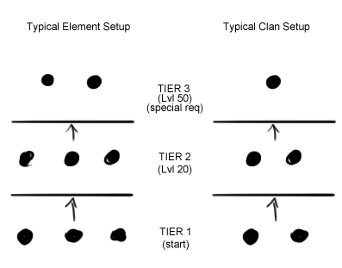

Status Effects

There are many attacks and skills that inflict certain status effects on top of the other things they do. Unless under special circumstances, these effects usually only last a few seconds. These effects include:

Burn | Light damage over time resulting from fire clinging to the player.
Poison | Damage over time from being poisoned.
Frozen | Rooted in place by ice.
Shock | Movement speed reduced by electrocution.
Bleed | Light damage over time which increases in severity as it goes untreated.
Stun | Cannot move or use commands due to disorientation from taking a hard, typically blunt hit.

JUTSU DESCRIPTION NOTES:
- Generally, as the level increases, so does the chakra cost unless otherwise stated
- 'Delay' refers to cooldown after usage. Low = around 1-15 seconds, Moderate = around 25-45 seconds, High = No less than 50 seconds, Very High = Roughly 2 minutes.
- Spreading projectile attacks make use of pixel movement.
- Taijutsu = Hand to hand/physical skills, Ninjutsu = 'Ninja magic', Genjutsu = Illusion techniques.
- For most jutsu, the player flashes the 'molding' state upon activating.

Common Jutsu

Common jutsu are basic ninja skills that most ninja should have. Common is the fastest leveling skill set, Tier 1 skills especially.
Bunshin  (Basic Clone)  TIER 1 | Lvl 1. Creates 3 intangible clones.  Lvl 2. Creates 4 intangible clones.  Lvl 3. Creates 5 intangible clones.  General clone function:  When no target is selected, clones automatically follow the player. When a target is selected, the clones will attempt to attack this player. In the case of these clones, no damage can be done. However, solid clones will deal damage based on a small fraction of the player's melee damage. Pressing Z while clones are in play will allow the player to switch positions with a random clone. Clones have 1 HP. | 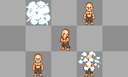
Kawarimi  (Replacement technique)  TIER 1 | Lvl 1. A toggle on skill. When active, allows 1 attack made against the player to be avoided on contact by moving the player 3-4 tiles in a safe direction and replacing the player with a log (or other nearby object). Remains active for 20 seconds without being hit before toggling off. Low cost when activated, high delay.  Lvl 2. Remains active for 30 seconds without being hit.  Lvl 3. Allows 2 attacks to be avoided. | 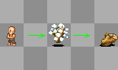
Henge  (Transformation)  TIER 1 | Lvl 1. Temporarily changes the appearance of the player to match that of the targeted mob. Lasts 30 seconds. 35% chance to 'fail' your attempt and appear with flawed/incorrect details. Low cost and delay.  Lvl 2. Lasts 45 seconds.  Lvl 3. Lasts 60 seconds. | 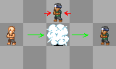
Shushin  (Body flicker)  TIER 2 | Lvl 1. Toggle on skill. While active, player may click on any nearby non dense tile (Within a 5 tile range) and will instantly be transported there. Lasts for 10 seconds. Low cost per click, moderate delay.  Lvl 2. Increases range to 7 tiles.  Lvl 3. Increases range to every tile visible on the screen. | 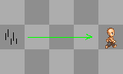
Kai  (Release)  TIER 2 | Lvl 1. When used, will attempt to forcibly free yourself from any genjutsu currently affecting you. Chance to dispel scales with Willpower. Moderate cost and delay.  Lvl 2. Increased effectiveness.  Lvl 3. Increased effectiveness, and now works on people within 1 tile away from you.

Elemental Jutsu

Jutsu cycle - Water <Advantage Water> Fire <Advantage Fire> Wind <Advantage Wind> Lightning <Advantage Lightning> Earth<Advantage Earth over Water>.

Water Amps Lightning
Wind Amps Fire

Fire (Katon)

The fire pool mainly focuses on covering wide ranges for moderate damage over time/continuous. The jutsu should have a chance of adding a 'burning' effect on targets where fire will cling to them and cause light damage over time for a short time.

Endan  (Fireball)  TIER 1 | Lvl 1. Fires a basic fireball projectile. 14 tile range, low chakra cost, low damage, low delay.  Lvl 2. Slightly higher damage and cost.  Lvl 3. Now leaves a trail of fire along its path. | 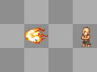
Housenka  (Multiple fireballs)  TIER 1 | Lvl 1. Fires 3 endan projectiles in a spreading pattern.  Lvl 2. Fires 4.  Lvl 3. Fires 6 | 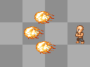
Goukakyuu  (Fire breath)  TIER 1 | Lvl 1. While shortcut key is held, ball of breathed fire is created in front of player doing continuous moderate damage to anyone it touches. Drains chakra for as long as it's held.  Lvl 2. Increased damage and cost.  Lvl 3. Increased damage and cost. | 
Dai Endan  (Great Fireball)  TIER 2 | Lvl 1. Fires a large fireball projectile. High damage, delay, and cost.  Lvl 2. Increased damage and cost. Leaves a trail of fire down the center of it's path (Aligned with the player).  Lvl 3. Increase damage and cost. Leaves trails of fire down it's 3 tile path. | 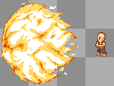
Hibashiri  (Running Fire)  TIER 2 | Lvl 1. Randomly creates flames tiles around the player in a 3x3 area. Low, continuous damage. Higher chance to cause burning effect.  Lvl 2. Area is upgraded to 4x4  Lvl 3. Area is upgraded to 5x5 | 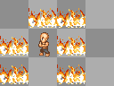
Karyuu Endan  (Fire Dragon)  TIER 2 | Lvl 1. Emits a breathed line of fire which deals continuous damage to anyone in it's path, for as long as the shortcut key is held. High damage and cost. 3 tile length.  Lvl 2. Increased range (5 tiles) and damage.  Lvl 3. Increased range (7 tiles) and damage. | 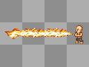
Haisekishou  (Ash Explosion)  TIER 3 | Lvl 1. First use emits a 3x3 cloud of ash in front of the player, which will say there for a maximum of 3 minutes. Using the skill again while the ash is out will detonate it. Very high damage, high cost.  Lvl 2. Increase damage and cost.  Lvl 3. Increase damage and cost. | 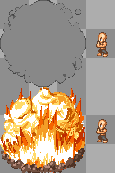
Gouryuuka  (Great Dragon Fire)  TIER 3 | Lvl 1. Fires one large homing fireball that goes after whoever the player has targeted. High damage, cost, and delay.  Lvl 2. Increased damage and cost.  Lvl 3. Allows player to fire 2 before any cooldown delay is applied. | 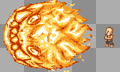

Water (Suiton)

The water jutsu set mainly specializes in high burst damage and knockback effects. Most water skills require that you be standing on a water turf or be in a wet environment (Rain) to use them. Using water jutsu also has a chance to create puddles of water on non water tiles along it's path. Water skills also put out flames left behind by fire moves (Great fireball, running fire, etc).
Suirou no Jutsu  (Water Prison)  TIER 1 | Lvl 1. Creates a small water prison infront of your character(holds one enemy) that gradually drains a tad bit health over time. Low duration and cost.  Lvl 2. Increased duration and cost.  Lvl 3. Increased duration, cost, and now able to create three prisons before delay. | 
Mizu Bunshin No jutsu  (Water Clone)  TIER 1 | Lvl 1. Creates 2 water clones of your character. Low chakra cost and duration.  Lvl 2. Creates 3 water clones of your character. Increased chakra cost and duration.  Lvl 3. Create 4 water clones of your character. Increased chakra cost and duration | 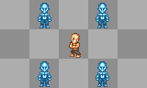
Suikoudan No jutsu  (Water Shark Projectile)  TIER 1 | Lvl 1. When on a tile of water; creates a homing column of water that goes to anyone that is targeted. Stretches about 5-7 tiles, Low Chakra cost and damage dealt.  Lvl 2. Stretches about 7-9 tiles. Increased chakra cost and damage dealt.  Lvl 3. Stretches about 9-11 tiles. Increase chakra cost and damage dealt. | 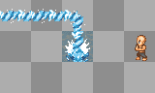
Baku Suishouha No Jutsu  (Bursting Water Collision Waves)  TIER 2 | Lvl 1. Creates a large pool of water infront of your character about 3 tiles wide and 8 tiles long. Has a push back effect. Medium Chakra Cost and delay  Lvl 2. Pool is increased to 5 tiles wide and 10 tiles long. Push Back effect. Increased Chakra cost and delay  Lvl 3. Pool is increased to 7 tiles wide and 12 tiles long. Push Back effect. Increased Chakra cost and delay. | 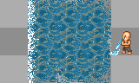
Daibakufu no Jutsu  (Grand Waterfall)  TIER 2 | Lvl 1. A water current shot in the direction your standing in. Push back effect. High damage and cost.  Lvl 2. Increased Damage and Cost.  Lvl 3. Increased Damage and Cost. | 
Mizurappa  (Violent Water Wave)  TIER 2 | Lvl 1. While shortcut key is held, a wave of water is created in front of player doing continuous moderate damage to anyone it touches. Drains chakra for as long as it's held.  Lvl 2. Increased damage and cost  Lvl 3. Increased damage and cost | 
Suigadan  (Water Fang Projectile)  TIER 3 | Lvl 1. Three sharp drilling projectiles that will utilize the ground water and rise around your target(Homing). High damage and cost.  Lvl 2. Increased damage and cost.  Lvl 3. Increased damage and cost. | 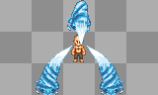
Suiryuudan no jutsu  (Water dragon projectile)  TIER 3 | Lvl 1. A controllable dragon projectile. High damage and cost.  Lvl 2. Increased damage, cost, and duration  Lvl 3. Increased damage, cost, and duration | 

Lightning (Raiton)

The lightning pool generally specializes in low-mid damage, high speed, and low cooldown and cost skills. All lightning moves have a chance to add a 'shocked' effect to players hit by it, which will lower that player's movement speed.

Raikoutama  (Lightning Ball)  TIER 1 | Lvl 1. Fires a high speed ball of lightning. Low damage, cost, and delay.  Lvl 2. Increased damage and cost.  Lvl 3. Now leaves a trail of electricity along it's path. | 
Raiton Bunshin  (Lightning Clone)  TIER 1 | Lvl 1. Spawns 3 clones. When these clones die, they explode in a flash of electricity, dealing light damage and a high chance of adding the shock effect to enemies within 1 tile of the explosion.  Lvl 2. Now spawns 4 clones.  Lvl 3. Now spawns 5 clones. | 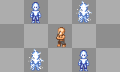
Raikousenkou  (Lightning Step)  TIER 1 | Lvl 1. Player instantly skips forward 4 tiles, leaving a trail of lightning which deals light damage to anyone along it's path. Low delay and cost.  Lvl 2. Increase damage, range increases to 5 tiles.  Lvl 3. Increases damage, range increases to 6 tiles. | 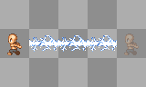
Chidori  (Thousand Birds)  TIER 2 | Lvl 1. Player takes a brief moment to charge a ball of lightning in their hand, then charges forward 5 tiles with it, cutting through everyone in their way. High damage, delay and cost.  Lvl 2. Increased damage, range increases to 6 tiles.  Lvl 3. Increased damage, range increases to 7 tiles. | 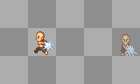
Lightning Blade  TIER 2 | Lvl 1. Player creates and swings lightning in the form of a sword, dealing moderate damage to enemies in the (red) area around them.  Lvl 2. Increased damage and stun chance.  Lvl 3. Increased damage and stun chance. | 
Chidori Eisou  (Chidori Spear)  TIER 2 | Lvl 1. When key is held, creates a long concentrated spear of lightning which reaches forward a maximum 4 tiles piercing through anyone within it's path. If key is released, the spear retracts. Moderate damage, low delay.  Lvl 2. Max range increase to 5 tiles.  Lvl 3. Max range increase to 6 tiles. | 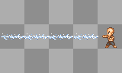
Ookamidan  (Lightning Wolf)  TIER 3 | Lvl 1. Creates a controllable wolf formed out of lightning and constantly moves forward at high speed, leaving a trail of lightning behind it. When activated, player is rooted in place and arrow keys control the direction the wolf moves in. The wolf cuts through any player it comes in contact with, dealing high damage and allowing it to continue on it's path for 5 seconds. High cost and delay.  Lvl 2. Increased damage.  Lvl 3. Increased damage, hits twice on contact. | 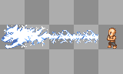
Chidori Nagashi  (Chidori current)  TIER 3 | Lvl 1. Creates a cage of lightning which traps enemy players inside and deals moderate continuous damage for the duration of the skill (4 seconds). High cost and delay.  Lvl 2. Increases duration to 6 seconds.  Lvl 3. Increases duration to 8 seconds. | 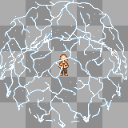

Wind (Fuuton)

The wind skill set focuses on keeping enemies at a distance with knockback and attacking them with long range, moderate damage, cutting projectiles. Cutting wind moves have a chance to add the “bleed” effect which deals minor damage over time that gradually increases as the bleed goes untreated for a short time.
Daitoppa  (Great Breakthrough)  TIER 1 | Lvl 1. Creates high air pressure around the player that moves with them for 15 seconds. Pushes back anyone within range.  Lvl 2. Increased chakra cost and duration  Lvl 3. Increased chakra cost and duration. | 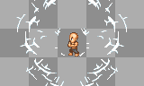
Renkuudan  (Drilling Air Projectile)  TIER 1 | Lvl 1. A small wind projectile.  Lvl 2. Increased chakra cost and damage. Slight Chance of Push back.  Lvl 3. Increased chakra cost and damage. Chance of Push back increased. | 
Atsugai  (Pressure Damage)  TIER 1 | Lvl 1. While shortcut key is held, a sharp blast of air pressure current is created in front of player doing continuous moderate damage to anyone it touches. Drains chakra for as long as it's held.  Lvl 2. Increased damage and cost  Lvl 3. Increased damage and cost | 
Sorakai no jutsu  (Sky Cutter)  TIER 2 | Lvl 1. Creates a slicing wind over you target enemy; doing damage and having a slight chance to cause a bleed effect.  Lvl 2. Increased damage, cost, and chance to cause bleed effect.  Lvl 3. Increased damage, cost, and chance to cause bleed effect. | 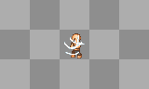
Kazekiri no jutsu  (Wind cutter)  TIER 2 | Lvl 1. Creates a slicing wind projectile that pushes your enemy back and has a slight chance to cause a bleed effect.  Lvl 2. Increased damage, cost, and chance to cause bleed effect.  Lvl 3. Increased damage, cost, and chance to cause bleed effect. | 
Reppushou  (Gale Wind Palm)  TIER 2 | Lvl 1. Creates a current of wind that sends things flying in its direction at high speed. Increases the speed and damage of projectiles sent through (going with the current) it while also continuously pushing anything going against the current away within it's area of effect in the direction It was cast.  Lvl 2. Increased tile coverage and cost  Lvl 3. Increased tile coverage and cost. | 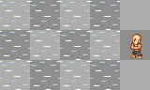
Kamaitachi  (Cutting whirlwind)  TIER 3 | Lvl 1. A small wind whirlwind that deflects and pushes back anything in its way. Shoots one projectile.  Lvl 2. Increased damage and cost.  Lvl 3. Increased damage and cost. Shoots 3 projectiles. | 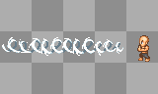
Dai Kamaitachi  (Great Cutting Whirlwind)  TIER 3 | Lvl 1. A tornado projectile that deflects and pushes back anything in its way. Shoots one projectile.  Lvl 2. Increased damage and cost. Shoots 3 spreading projectiles.  Lvl 3. Increased damage and cost. Shoots 5 spreading projectiles. | 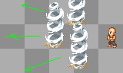

Earth (Doton)

Earth specializes in both slower high damage attacks with significant (More than 1 tile per hit) knockback, and defensive skills.

Earth Bullet  TIER 1 | Lvl 1. Fires a high impact mud projectile. Moderate damage, low delay.  Lvl 2. Increased damage.  Lvl 3. Increased damage. | 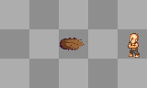
Doro Gaeshi  (Earth Wall)  TIER 1 | Lvl 1. Creates a small wall of earth in front of the player that defends against attacks. Absorbs a maximum of 200 damage or 1 minute before breaking. Deals moderate damage and knocks back anyone standing on the tile it appears on. Low cost, Moderate delay.  Lvl 2. Increases maximum absorption to 400 and lowers delay between uses.  Lvl 3. Increases maximum absorption to 600 and lowers delay between uses. | 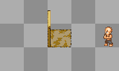
Doryuu Taiga  Earth Flow River  TIER 1 | Lvl 1. Creates a large mud flow in front of your character about 3 tiles wide and 8 tiles long. Players caught in the mud move slower and take small damage over time. Medium Chakra Cost and delay  Lvl 2. Flow is increased to 5 tiles wide and 10 tiles long. Increased duration.  Lvl 3. Flow is increased to 7 tiles wide and 12 tiles long. Increased duration.
Doryuudan  (Mud Dragon)  TIER 2 | Lvl 1. Spawns a stationary mud dragon head in front of the player which continuously fires earth bullets at the targeted enemy for 10 seconds. Moderate cost and delay.  Lvl 2. Increases lifespan to 20.  Lvl 3. Increases lifespan to 30. | 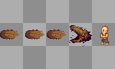
Doryuu Heki  (Giant Earth Wall)  TIER 2 | Lvl 1. Creates a larger wall of earth in front of the player. Absorbs a maximum of 2000 damage or lasts 1 minute before breaking. Deals high damage and knocks back anyone standing on the tiles it appears on. High cost and delay.  Lvl 2. Increases absorption to 4000  Lvl 3. Increases absorption to 6000 | 
Dorou Doumu  (Earth Dome)  TIER 2 | Lvl 1. Creates a dome of earth that surrounds the targeted mob and those in the 3x3 area around them, trapping them inside for 5 seconds. Those that are trapped have their chakra slowly drained from them per second. Can be broken from the inside after dealing a certain amount of damage. Moderate cost, high delay.  Lvl 2. Increases damage tolerance and maximum length to 10 seconds.  Lvl 3. Increases damage tolerance and maximum length to 15 seconds. | 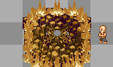
Doryou Dango  (Earth Dumpling)  TIER 3 | Lvl 1. Player calls up a huge chunk of earth up and rolls it forward. Very high damage, doesn't let other projectiles stop its advance. High cost and delay. High chance to stun.  Lvl 2. Increased damage.  Lvl 3. Increased damage. | 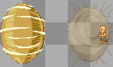
Doryuu Katsu  Earth Split  TIER 3 | Lvl 1. Player creates a large chasm in the ground in front of them. While this chasm is open, the player is rooted in place. If the skill is activated again while the chasm is open, it will quickly close on any player standing in it, dealing high crushing damage. High cost and delay.  Lvl 2. Increased damage.  Lvl 3. Increased damage. | 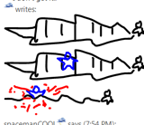

Clans [F01]

Aburame

Aburame(Pet Master/Scout)
Stat Focus: Dexterity, Intelligence
Stat Weakness: Defense, Strength
Game Strengths: Tracking. Commands for bugs to do various task in support, offensive, and defensive. High Dexterity Start.

Jutsu List
Kikaichuu No Jutsu  (Destruction Bugs) | Aburame is clan that utilize bugs as pets in battle. In Ninja universe; the aburame clan will be able to create bugs that will do different stuff in battle. Whether its Offense, Defense, or the Supportive role.  Offense -  Destruction Bugs – Basically the demolition pets. The aburame clan player can order these type of bugs to do certain attacks.  Regular Attack – Swarm of bugs than can be controlled with the mouse to attack.  Exploding Attack – Player inserts destructive chakra into bugs. Bugs act like a ticking time bomb.  Poisonous bugs – Poisonous bugs are exactly like regular attack but with the added poisonous effect.  Defense -  Defensive Beetles – Defensive Beetles are large bugs that can be used to ways in battle. One being the create a beetle wall when blocking. Two being able to create a full body armor of beetles.  Supportive -  Relief Bugs – Relief bugs can do a number of things in the medical area. Dispatching relief bugs into your body can:  - Stop Poison  - Stop Bleeding  - Remove a sealing effect with half chance of failing.  Chakra Leech – Chakra leechers allow you too shoot a projectile filled with that will hit an enemy and smother them. Once smothered; the leechers will gradually suck away the enemy's chakra and give it back to you.  Tracking Female – When a tracking female is dispatched and lands on an enemy; wherever that player goes the aburame player will have a arrow directing them right to their position for a period of time.

Akimichi

Akimichi(Barbarian/Tank)
Stat Focus: Strength, Defense
Stat Weakness: Speed, Itelligence, WillPower
Game Strengths: High Strength and HitPoint start. High Damage dealer with Hand-To-Hand combat. Defense like a Tank.

Jutsu List
Nikudan Sensha  (Human Bullet Tank)  TIER 1 | Lvl 1. Player inflates and rolls into a giant rolling ball. Player can deal continuous moderate damage by rolling into enemies, knocking them back on contact. Moderate cost and delay. Moderate chance to stun.  Lvl 2. Increased speed.  Lvl 3. Increased speed. | 
Quake  TIER 1 | Lvl 1. Player will jump into the air and come down with their weight, creating a shockwave which breaks up the ground in a 3x3 area around them. Any player standing on affected tiles receives moderate damage. Costs moderate stamina, low delay. Low chance to stun.  Lvl 2. Increases damage dealt.  Lvl 3. Increases range to 5x5. | 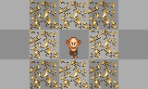
Nikudan Hari Sensha  (Spiked Bullet Tank)  TIER 2 | Lvl 1. Player inflates and rolls into a giant rolling ball wrapped in kunai. Player can deal high damage by rolling into enemies, knocking them back on contact. High cost and delay, requires 10 kunai.  Lvl 2. Increased damage  Lvl 3. Increased damage | 
Baika  (Multi-Size)  TIER 2 | Lvl 1. Toggle on/off. Player doubles in size, greatly increasing their strength, but lowering their movement speed.  Lvl 2. Increases strength buff.  Lvl 3. Increases strength buff. | 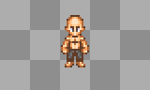
Choudan Bakugeki  (Butterfly Bombardment) | Lvl 1. Converts calories to chakra using a special red pill. Chakra forms in the back giving the look of wings. Increases movement speed, strength, and defense according to amount of calories used. Requires Red pill and calories. Very high delay. Does not level. | 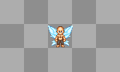

Hyuuga

Hyuuga(Scout/Counter)
Stat Focus: Speed, Dexterity
Stat Weakness: Defense, Stamina
Game Strengths: Scouting/Player Detection, hand to hand combat. High Speed and Dexterity Start.

Jutsu List
Byakugan  (White Eye)  TIER 1 | Lvl 1. Toggle on/off. Activates Byakugan, which allows a person to see vital points on others. Gives normal melee attacks an added chance to also deal small amount of damage to enemy chakra and increases critical rate. Also used as a prerequisite to some moves. Drains small amounts of chakra while active. Automatically toggles off when chakra is dangerously low.  When active, puts special marking over clones to show they aren't real.  Lvl 2. Increased chance to attack chakra.  Lvl 3. 100% chance to attack chakra. | 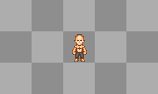
Byakugan Sight  TIER 1 | Lvl 1. While Byakugan is active, allows player to go into 'sight' mode, where their body stays in place but they can move their view around within a certain range (The distance of 1 screen?). Taking damage cancels sight and brings the control back to the player's character. Does not cost chakra, as it is a general function of Byakugan.  Lvl 2. Increases allowed view range.  Lvl 3. Increases allowed view range. | 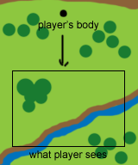
Hakke Kuushou  (Air Palm)  TIER 1 | Lvl 1. Fires 4 spreading chakra wave projectiles forward. Each one has the potential to knock enemies back. Low cost, delay, and damage per projectile.  Lvl 2. Increases damage and projectile count to 6.  Lvl 3. Increases damage and projectile count to 8. | 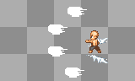
Hakke Rokujuuyonshou  (64 Palms)  TIER 2 | Lvl 1. Requires Byakugan. Creates a large circular symbol on the ground. Any other player caught in this space Is frozen in place while the player automatically rapidly hits them 64 times over a few seconds.  If 1 target is caught, the player will focus all 64 hits on that player. If more than 1 is caught, the player will divide the attacks between the players, hitting them a few times, then appearing in front of the next, hitting them, etc until a total of 64 hits is reached. Damage dependent on melee damage and # of successful hits, moderate cost, high delay.  Lvl 2. Increased damage.  Lvl 3. Increased damage. | 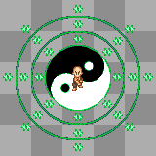
Hakkeshou Kaiten  (Heavenly Spin)  TIER 2 | Lvl 1. While the shortcut key is held, player creates a high speed rotating defensive barrier of chakra around themselves. Any people or projectiles that come in contact with it are redirected/knocked away. Drains moderate amount of chakra as long as it's held, moderate delay afterward.  Lvl 2. Slightly DECREASES chakra cost to maintain.  Lvl 3. Slightly DECREASES chakra cost to maintain. | 
Hakke Hyakunijuuhachishou  (128 palms)  TIER 3 | Lvl 1. Functions the same as the lvl 1 64 palms technique, only affects a larger range ,deals 128 hits, costs more chakra, and has a higher cooldown delay.  Lvl 2. Increased damage.  Lvl 3. Increased damage. | 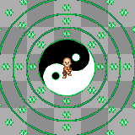

Inuzuka

Inuzuka(Pet Master/Barbarian)
Stat Focus: Speed, Stamina
Stat Weakness: Defense, Slight HP
Game Strengths: Tracking. Close-Mid Range Combat. Dogs. High Stamina Start.

Jutsu List
Shikyaku no Jutsu  (Four Legged Technique)  TIER 1 | Lvl 1. Slight buff in Speed, Stamina, Strength. Appearance changed.  Lvl 2. Buff increased.  Lvl 3. Buff increased. | 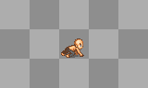
Juujin Bunshin  (Beast-Man Clone)  TIER 1 | Lvl 1. Dog is transformed to look like your character in shikyaku no jutsu, with a slight buff your dogs speed, stamina, and strength.  Lvl 2. Buff Increased.  Lvl 3. Buff Increased. | 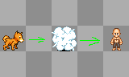
Dynamic Marking  TIER 1 | Lvl 1. Your dog will use its pee to mark a target for tracking.  Lvl 2. Duration Increased  Lvl 3. Duration Increased. | 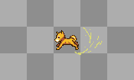
Inuzuka Ryuu.  (Rare Beast Transformation)  TIER 2 | Lvl 1. Appearance changes into a Transformed Two-Headed dog. Buff increase in Speed and Strength.  Lvl 2. Buff Increased  Lvl 3. Buff Increased | 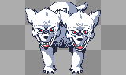
Tsuuga  (Piercing Fang)  TIER 2 | Lvl 1. Player turns into a controllable drilling attack which constantly moves in the direction it's facing. Front of the attack knocks enemies back.  Lvl 2. Increased damage and cost  Lvl 3. Increased damage and cost | 
Gatsuuga  (Dual Piercing Fang)  TIER 3 | Lvl 1. Dual Spinning controllable projectile with push back effect. High Damage and cost.*Note. Dog must be Juujin bunshin.  Lvl 2. Increased damage and cost  Lvl 3. Increased damage and cost. | 
Garouga  (Dual Wolf Fang)  TIER 3 | Lvl 1. Large Spinning controllabe projectile with push back effect. High damage, Critical Dealer, and cost. *Note; Must be in Inuzuka Ryuu to perform this jutsu.  Lvl 2. Increased damage and cost  Lvl 3. Increased damage and cost. | 

Nara

Nara(Tactician/Support)
Stat Focus: Intelligence, Dexterity
Stat Weakness: Defense, Willpower
Game Strength: Excellent support clan. Uses skills that holds and manipulates enemies, potentially turning them against eachother.

Jutsu List
Kage Mane  (Shadow Imitation)  TIER 1 | Lvl 1. Drains small amounts of chakra while active. Player is rooted in place and takes control of a stretching/bending shadow. If the end of the shadow comes in contact with another player, that player is frozen in place as well and loses control of their character.  - Once a player is caught, they mimic/mirror the actions of the controlling player (Shadow user punches, caught player punches, etc).  - If the controlling player uses a jutsu that the controlled player has, then the controlled player will use it too.  Low delay. Automatically cancels when attacked or at dangerously low chakra.  Lvl 2. Once a player is caught, allows the player to spawn another shadow from the caught player's position. Also increases speed.  Lvl 3. Allows the player to spawn a 3rd shadow from a 2nd caught person. Also increases speed. | 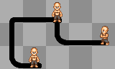
Retract | Command to cancel Kage Mane.
Kage Mane Choke  TIER 1 | Lvl 1. Can only be used on a target caught with the shadow.  Creates a shadow hand on all caught targets which creeps up from the shadow and chokes them. Deals continuous damage with increasing severity over 10 seconds. Having kage mane canceled through Retract or taking damage will cancel the choke as well. Moderate cost and delay.  Lvl 2. Increases duration to 15 seconds.  Lvl 3. Increases duration to 20 seconds. | 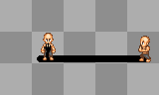
Kage Nui  (Shadow Sewing)  TIER 2 | Lvl 1. Works like Kage Mane, only instead of holding people, the tip of the shadow raises from the ground and flails wildly, continuously whipping anything it touches. Moderate damage and delay.  Lvl 2. Increases damage and speed.  Lvl 3. Increases damage and speed. | 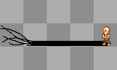
Shadow Knife  TIER 2 | Lvl 1. Requires Chakra knife.  Throws a chakra infused knife which, on contact with another player, will freeze them in place like Kage Mane, but the player is not controlled. Low cost. Delay and damage equal to kunai.  Lvl 2. Throws 3 spreading knives. Requires 3 chakra knives.  Lvl 3. Throws 5 spreading knives. Requires 5 chakra knives. | 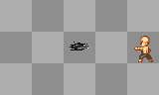
Shadow Web  TIER 3 | Lvl 1. Creates large 'web' of stretched shadows around the player. Any other player stepping on the shadows becomes caught and controlled. Much higher chakra drain cost than regular Kage Mane, high delay.  Lvl 2. Lowers drain cost.  Lvl 3. Lowers drain cost. | 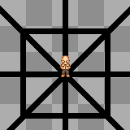

Uchiha

Uchiha(Tactician/Counter)
Natural Element Affinity: Fire
Stat Focus: WillPower, Itelligence
Stat Weakness: Strength, Defense
Game Strengths: High WillPower Start. Sharingan Copy(5m)

The Uchia clan is largely dependent on the Fire element set for their offensive skills. Therefore, it's available to them from the moment their character is made, and they receive a small damage bonus to fire skills. Their clan skills revolve around the Sharingan and it's different forms. Therefore there are only 2 tiers in this clan's skill set. The 2nd tier is unlocked after completing a special quest and meeting certain requirements. Depending on which path the player chooses, they will get 1 form of the Mangekyou and the skills that go with it.

To unlock Mangekyou Sharingan
Complete the "Uchiha Heratige" quest. Kill 1600 people, Watch 200 people die, and use copied jutsus 500 times with three tomo sharingan active Have 3 tomo sharingan active for a total of 25,000 cycles. Do a total of 15,000 damage with 3 tomo sharingan active.

Jutsu List
Sharingan  (Copy Eye)  TIER 1 | Lvl 1. Toggle on/off skill. While active, drains small amounts of chakra. Automatically turns off when chakra is dangerously low.  Sharingan is an ability that gives the user the ability to read genjutsu, taijutsu, and ninjutsu by seeing chakra and muscle movement. While active, player can see the remaining chakra of other players around them, as well as have an increased resistance to genjutsu.  Lvl 2. Now:  - Allows the last elemental jutsu or taijutsu the player saw used by another player/npc to be used (If chakra/stamina requirements are met).  - Shows remaining chakra and stamina of other players.  - Puts special marking over clones to show they aren't real, and players affected by genjutsu.  - When player Is hit by a melee attack, has a chance to automatically hit back (If attacker Is in range).  Lvl 3. Now:  - Allows the last 2 elemental jutsu or taijutsu the player saw to be used (If chakra/stamina requirements are met).  - Replaces Genjutsu resistance chance with Genjutsu reversal chance. Genjutsu used on the player with active sharingan has a chance to be inflicted on the user instead. | 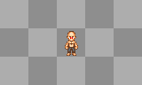
Paralysis  TIER 1 | Lvl 1. Requires active sharingan. If successful, will freeze targeted player in place for a few seconds, with the affected player seeing the illusion large rusted spikes have been driven into themselves, restricting their movement. Moderate cost, high delay.  Lvl 2. Increased effectiveness.  Lvl 3. Increased hold time. | 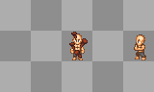
Mangekyou  (Advanced copy eye)  TIER 2 | Offers all the advantages of Lvl 3 Sharingan and allows Mangekyou jutsu to be used at the cost of more rapid chakra drain. If Sharingan is active when Mangekyou is active, Sharingan effect is replaced.  In order to gain the skills which Mangekyou awakens. Certain eyes need to be mastered.
Amateratsu  (Black Fire)  TIER 2 | Requires Right Eye of Mangekyou mastered.  Lvl 1. Fires a large black fireball projectile. Very High damage, delay, and cost. 100% chance to inflict burning effect.  Lvl 2. Increased damage and cost. Leaves a trail of fire down the center of it's path. Touching the flames will inflict burning effect.  Lvl 3. Increase damage and cost. Leaves 3 trails of fire down it's path. | 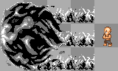
Tsukuyomi  (God of the Moon)  TIER 2 | Requires Left eye of Mangekyou mastered.  Lvl 1. Inflicts powerful illusion on targeted player. Player completely freezes, screen fades to black, and fades back in to player seeing himself trapped in a dark world where they appear to be (But aren't really) taking massive damage. After 10 seconds, fades to black and fades back in to the game world. High cost and delay. Cannot be dispelled by Kai.  Makes use of a large overlay. Player sees this dark world on their screen but is actually standing wherever they were when the illusion hit them, where they can be attacked with no means of defending themselves.  Lvl 2. Increases time to 12 seconds.  Lvl 3. Increases time to 15 seconds. | 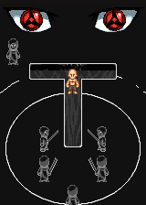
Kamui  (Vortex)  TIER 2 | Requires use of copied jutsus 200 times in addition to the mangekyou requirements.  Lvl 1. Creates a spinning vortex on top of a targeted enemy which pulls anyone within a 5x5 range into it's center. Deals continuous damage to anyone within it's range. The damage dealt increases the closer to the center the affected persons are. High cost, very high delay.  Lvl 2. Increases strength of the pull.  Lvl 3. Increases range to 7x7. | 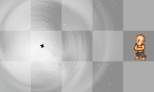

Haku

Haku(Ice User)-(Tactician/Counter)
Natural Element Affinity: Wind, Water
Stat Focus: Speed, Dexterity.
Stat Weakness: WillPower, Defense
Game Strengths: Start off with their two elements(Wind, Water). High Speed/Dexterity start. High Critical Dealer

Jutsu List
Mist  TIER 1 | Lvl 1. Creates mist in a 3x3 area around the player. While on a tile affected by the mist, it Is possible to use Water jutsu without being on a water tile and all Haku and Water jutsu damage is slightly increased. A maximum of 3 Water or Haku clan jutsu can be used on a mist affected tile before it disappears, or will disappear on it's own over time. Low cost, moderate delay.  Lvl 2. Increases area to 5x5, 4 uses.  Lvl 3. Increases area to 7x7, 5 uses. | 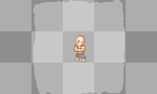
Ice Needles  TIER 1 | Lvl 1. Fires 4 ice needle projectiles in a spreading pattern. Low damage per projectile, low delay, low cost.  Lvl 2. Fires 6, increased damage per.  Lvl 3. Fires 8, increased damage per. | 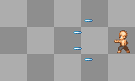
Sensatsu Suishou  (Thousand Water Needles)  TIER 2 | Lvl 1. Rains countless needles of ice down on targeted mob. Stays on top of them even as they move. Deals moderate damage per second for 5 seconds. Moderate cost and delay.  Lvl 2. Increases duration to 10 seconds.  Lvl 3. Increases duration to 15 seconds. | 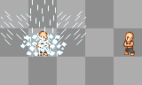
Ice Spikes  TIER 2 | Lvl 1. Creates a straight line of rising jagged ice which reaches a maximum 20 tiles in front of the user. The line doesn't stop unless it reaches it's maximum length or hits a dense object/tile, which allows it to cut through players along it's path. moderate damage, cost, and delay.  Lvl 2. Increased damage and now inflicts a 'Freeze' effect where enemies that are hit become frozen in place briefly. These frozen players are still able to change direction and attack, but cannot move from the tile.  Lvl 3. Increased damage, now creates 3 parallel lines. | 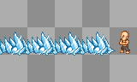
Makyou Hyoushou  (Ice Mirrors)  TIER 3 | Lv 1. Creates multiple mirrors of ice, each with the image of the person who created them. These mirrors surround the player and those within it's reach. The player can then move freely into, between, and out of these mirrors by clicking the one they wish to go to or stepping out, while the people trapped within cannot. While inside the mirrors the player can attack/use other jutsu, and can be damaged if someone attacks the mirror they are in. Players trapped within the mirror cannot use Body Flicker or Lightning Step to escape. Mirrors last 15 seconds before disappearing. High cost and delay.  Lvl 2. Increases duration to 20 seconds.  Lvl 3. Increases duration to 30 seconds. | 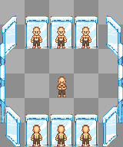

Kaguya

Kaguya(Tactician/Tank)
Stat Focus: Dexterity, Defense
Stat Weakness: WillPower, Intelligence
Game Strengths: Highest Defense start in game due to body structures being the strongest. High Dexterity start. High Critical dealer.

A clan famous for their ability to manipulate their bone structure, which lets them remove and rapidly regnerate them and use them as deadly weapons.

Jutsu List
Bone Sword  TIER 1 | Lvl 1. Attacks with a sword made from bone. Moderate damage and a high chance of adding “bleed” effect. Low cost.  Lvl 2. Increased damage.  Lvl 3. Increased damage. | 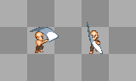
Teshi Sendan  (Bone Bullet)  TIER 1 | Lvl 1. Fires 5 spreading finger bone projectiles. Low damage per bullet, low cost, mid delay (Like a shotgun, most effective when used up close).  Lvl 2. Increased damage.  Lvl 3. Now fires 10 projectiles. | 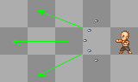
Bone Whip  TIER 2 | Lvl 1. Swings a spinal cord whip, dealing damage to anyone on the 3 tiles in front of the player. (Bone sword w/ increased ranged and w/o bleed effect).  Lvl 2. Increased damage.  Lvl 3. Increased damage. | 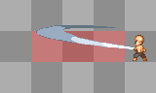
Karamatsu no Mai  (Ribcage Spikes)  TIER 2 | Lvl 1. A toggle on skill. When the skill is active, it adds a effect to blocking. When the player blocks while the skill is active, the bone spikes extend from the player, dealing high damage to any enemies within the 3x3 range. However, blocking will cost chakra.  Lvl 2. Decreased chakra cost  Lvl 3. Decreased chakra cost, increased damage. | 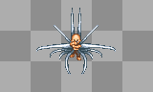
Sawarabi no Mai  (Bone Forest)  TIER 3 | Lvl 1. Creates a wave of bone spikes emerging from the ground, appearing on random tiles along the 15 tile path. Deals high damage to anyone standing on affected tiles.  Lvl 2. Increases damage and number of affected tiles.  Lvl 3. Increases damage and number of affected tiles. | 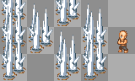

Puppet Master

Stat Focus: Intelligence, Dexterity
Stat Weakness: Willpower, Strength
Game Strengths: Solo friendly. Very flexible pet which can be reconfigured to fit many different roles. Also allows the player to keep at a safe distance and attack while the puppet does it's part as well.

Puppet Master works differently from other clans in that it's moveset is made up of commands for their puppet pet, not actual jutsu. Puppets are pieced together from different body parts (Head, body, arms, legs). Depending on the body parts, the different commands will do different things. Parts obtained through special puppet shop located in the sand village or quest rewards/etc.

Jutsu List
Summon/Dismiss | Calls and dismisses puppet. Summoning requires a small initial amount of chakra, on top of chakra slowly being drained as the puppet is active. The puppet must have at least have a body and legs. High delay applied after Puppet is dismissed. Puppet is summoned at full health. | 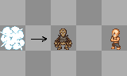
Attack | Toggle on/off. Puppet will attempt to melee attack targeted enemy. | 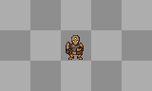
Head Special | Puppet will use the special ability of the head part if a head is attatched. | 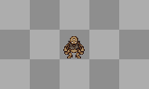
Arms Special | Puppet will use the special ability of the arms part if arms are attatched. | 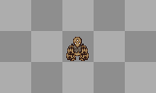

Sand Manipulator

Stat Focus: Intelligence, Defense
Stat Weakness: Willpower, Strength
Game Strengths: High defense/survivability. Takes advantage of a sand entity that serves as both a means of defense and offense.

Jutsu List
Sand Mass  TIER 1 | Lvl 1. Collects nearby sand and dirt and forms it into a floating mass which follows on top of the player. While the mass and the player are together, the mass will protect the player by blocking 50% of incoming damage while standing still, or 25% while moving. Costs small chakra drain to maintain. Moderate initial cost and delay.  Lvl 2. Decreases chakra drain.  Lvl 3. Decreases chakra drain. | 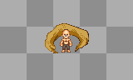
Suna Shuriken  (Sand Shuriken)  TIER 1 | Lvl 1. Fires 3 spreading compressed sand projectiles. Low damage per. Low cost and delay.  Lvl 2. Fires 4 projectiles.  Lvl 3. Fires 5 projectiles. | 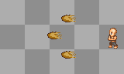
Sabaku Kyuu  (Desert Coffin)  TIER 2 | Lvl 1. Requires active Sand Mass.  When used, the mass will leave it's creator and chase down the targeted mob, attempting to encase them. If successful, the target will be held, with the opportunity to break free by rapidly tapping S (Some sort of icon or animation will be shown to instruct the player how to free themself). If the player breaks free, the Sand Mass must be summoned again. Moderate cost and delay.  Lvl 2. Increases chase speed of sand mass and escape difficulty.  Lvl 3. Increases chase speed of sand mass and escape difficulty. | 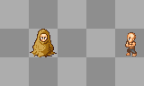
Suna Shigure  (Sand Shower)  TIER 2 | Lvl 1. Requires active Sand Mass.  The mass explodes and fires a massive amount of small, high speed bullets of sand in the direction the player is facing. Sand Mass disappears after use. Moderate damage per projectile, high cost, moderate delay.  Lvl 2. Increases bullet count and delay.  Lvl 3. Increases bullet count and delay. | 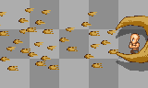
Sabaku Sousou  (Desert Funeral)  TIER 3 | Lvl 1. Requires a player be trapped in a Desert Coffin.  Desert Coffin sand rapidly compresses and the player trapped inside is crushed. Coffin disappears afterward and player is freed. Very high damage, cost, and delay.  Lvl 2. Increased damage.  Lvl 3. Increased damage. | 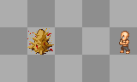

Other/Custom

Players who choose Other as their starting clan will be prompted with extra character customization options. They will be allowed to pick a starting element, stat focus (2), talents (2), and a specilization from the beginning.

Specializations

Specializations are a kind of sub-class package deal to add another layer of uniqueness/customization to a character, as well as stat bonuses and exclusive talents. They are available to learn from certain NPC's throughout the world once players reach a certain level. Only one per character, and cannot be changed.

Medical Ninja

Stat Bonus(Focus): Intelligence, Dexterity.
- The healers of Ninja Universe. They specialize in a good ammount of healing techniques but can also use their medical skills in hand to hand combat. Know the body well; so expect to see alot of criticals.

Mend | Lvl 1. Holding the key heals you or a player a tile infront of you.  Lvl 2. Decreased chakra cost  Lvl 3. Decreased chakra cost. Heals quicker.
Zone Mend | Lvl 1. Heals you and players around you within a 3x3 tile range.High Chakra Cost.  Lvl 2. Increased tile range. 5x5. Increased chakra cost.  Lvl 3. Increased tile range. 8x8. Now can heal everyone within your squad while in battle.
Revive | Lvl 1. A technique that revives a fallen comrade. The revive process will have duration to it. Revives person with 15% health returned.  Lvl 2. Decreased duration(Revives quicker). Decreased chakra cost. Revives person with 25% health returned.  Lvl 3. Decreased duration(Revives quicker). Decreased chakra cost. Revives person with 50% health returned.
Chakra Scalpel | Lvl 1. A chakra like scalpel coats the players hands. Used to cut enemies in hand to hand combat. High Critical chance and chance to bleed.  Lvl 2. Increased critical chance and chance to bleed  Lvl 3. Increased critical chance and chance to bleed.

Genjutsu (Illusion) Ninja

Stat Bonus(Focus): WillPower, Intelligence.
- The tricksters of Ninja Universe if you will. They sepcialize in a wide range of illusion techniques that gets into the minds of players and affects them mentaly.

Jutsu List
Pitch Black | Lvl 1. An illusion that envelopes your enemy in complete darkness.  Effects: Stamina Drain. Player Immobilized.  Lvl 2. Increased Duration and Chakra Cost.  Lvl 3. Increased duration and Chakra Cost.
Clone Illusion | Lvl 1. Shows your enemy a ton of clones of yourself. Leaving them in a state of confusion in battle  Effects: Player fights clones in confusion.  Lvl 2. Increased duration and chakra cost  Lvl 3. Increased duration and chakra cost.
Monstrous/Murderous Genjutsu | Lvl 1. An illusion showing your enemy a dark monstrous screen; instilling “fear” in them.  Effects: Stamina drain. After images of some scary monster on screen along with tangled controls. Instills fear.  Lvl 2. Increased duration for the effects. Increased chakra cost.  Lvl 3. Increased Duration for the effects. Increased chakra cost.
Death Wasteland | Lvl 1. Shows your enemy a wasteland with a few dead bodies around. Screen then takes a melting form. High Chakra cost.  Effects: Stamina drain. Instills fear.  Lvl 2. Increased duration and chakra cost.  Lvl 3. Increased duration and chakra cost.

Fuunjutsu (Sealing/Debuff) Ninja

Ninja who use seal skills to handicap their enemies. Recieves bonus Intelligence and Willpower.

Jutsu List
Chakra Sealing | All seals appear as a 5x5 effect around the caster and affect anyone standing in that space except the caster.  Lvl 1. A seal made to interfere with the flow of chakra as well as a person's ability to control it. Temporarily decreases the maximum chakra of any other player within it's range by 10%, as well as slightly increasing the cost of their chakra using jutsu. When it wears off, the person's maximum chakra and jutsu cost returns to normal, but any chakra lost from the decrease in maximum chakra does not return. Lasts 60 seconds, moderate cost and delay.  Lvl 2. Increases the max chakra loss to 15%  Lvl 3. Increases the max chakra loss to 25%
Cursed Palm | Lvl 1. Toggle on/off. While active, gives each punch a small chance to inflict ONE random status effect on anyone hit by it.  Lvl 2. Increases chances.  Lvl 3. Increases chances, allows 2 status effects to be inflicted.
Life Sealing | Lvl 1. Temporarily halts another player's ability to regenerate/recover health. Standing regen, resting, and other means of recovering health, chakra, or stamina are ineffective. Lasts 60 seconds. High cost and delay.  Lvl 2. Increases duration to 90 seconds.  Lvl 3. Increases duration to 2 minutes.
Arm Sealing | Lvl 1. Temporarily disables the use of player's arms. Disables use of most jutsu (Eye techniques still available) and actions that require arms (Punching, throwing). 15 second duration. Very high cost, moderate delay.  Lvl 2. Increases duration to 20 seconds.  Lvl 3. Increases duration to 25 seconds.

Clone Ninja

Ninja who specialize in using the shadow clone technique to perform hand to hand combos and various formations. Recieves bonus to Strength and Defense

Jutsu List
Kage Bunshin  (Shadow Clone) | Lvl 1. Creates 3 solid clones. Low cost and delay.  Lvl 2. Creates 4 solid clones.  Lvl 3. Creates 5 solid clones.
Bunshin Taiatari  (Clone Ramming) | Lvl 1. One available clone gets behind the player and launches them forward 5 tiles. Anyone in the way of the player's path takes moderate damage and is knocked back a considerable distance, dealing damage to and knocking back anyone that they run into along the way. Moderate delay  Lvl 2. Increases damage.  Lvl 3. Increases damage.
Lvl 1. Available clones appear around the target, restricting movement, and all kick the target at once, inflicting moderate damage and a high chance of stunning the target. High delay.

Lvl 2. Increased damage and stun chance.

Lvl 3. Increased damage. 100% chance to stun.
Tajuu Kage Bunshin  (Mass Shadow Clone) | Lvl 1. Creates 6 solid clones at the cost of a very high amount of chakra. Very high delay.  Lvl 2. Creates 8 clones.  Lvl 3. Creates 10 clones.

Sword Ninja

Ninja who specialize in the mastery of swordsmanship.

Recieves bonus to Strength and Dexterity

Jutsu List
Chakra Blade | Lvl 1. Toggle on/off. Using the player's first elemental affinity, sword attacks inflict an added effect depending on the element. Drains small amounts of chakra while active.  Effects:  Fire – Chance to inflict burn  Wind – Chance to inflict bleed  Earth – Chance to inflict stun  Lightning – Chance to inflict shock  Water – Chance to trap enemy in Water Prison  Lvl 2. Increases chances.  Lvl 3. Increases chances.
Flurry | Lvl 1. Temporarily increases attack speed with sword weapons. Wears off after 20 seconds. Moderate stamina cost, high delay.  Lvl 2. Wears after 40 seconds.  Lvl 3. Wears after 60 seconds.
Deep Cut | Lvl 1. Heavy sword attack dealing high damage and inflicting bleed. High stamina cost, moderate delay.  Lvl 2. Increased damage.  Lvl 3. Increased damage.
Sword Spin | Lvl 1. Player spins around once with his sword, cutting anyone 1 tile away and knocking them back. Moderate damage and cost, low delay.  Lvl 2. Increases damage and strength of knockback.  Lvl 3. Increases damage and strength of knockback.

Archer Ninja

Stat Bonus(Focus): Dexterity, Itelligence.
- The long range supporters of Ninja Universe. They stay back and envelope players in their arrows. Knowlegde of the bow and the body grants them High Critical chances.

Jutsu List
Shot | Lvl 1.Begins with an accurate single shot with high critical and bleed chance.  Lvl 2. Now can add exploding notes to the shot. Increased damage, critical and bleed chance.  Lvl 3. Now shoots two shots simutanelously. Exploding notes still can be used. Increased damage, critical and bleed chance.
Controlled Shot | Lvl 1. A high accuracy shot that can be controlled with movement arrows. High Chance of critical and bleed chance.  Lvl 2. Increased chakra cost, critical and bleed chance.  Lvl 3. Increased chakra cost, critical, and bleed chance.
Chakra Shot | Lvl 1. Using their chakra affinity, Archers can add special effects and increase the damage of their arrows.  Effects:  Fire - A burn effect is added with increased damage.  Wind – A cut effect with bleed chance is added with increased damage.  Earth – A rock solid effect with high physical damage is added. Craters are made with every shot.  Lightning – A paralyze effect is added with increased damage.  Water – A bubbles effect is added that sometimes creates a puddle with every shot or creates a water sphere to hold the players whos been shot. Increased damage aswell.  Lvl 2. Increased damage and chakra cost.  Lvl 3. Now shoots 3 shots at once. Increased damage and chakra cost.
Arrow rain | Lvl 1. Shoots 6 arrows with high chance of critical and bleed.  Lvl 2. Shoots 2 sets of 6 arrows before cool down. Increased chakra cost, chance of critical and bleed.  Lvl 3. Shoots 3 sets of 6 arrows before cool down. Increased chakra cost, chance of critical and bleed.

Villages/World [G01]

World map

All outside world maps were designed to be stitched together so that walking between them can be made seamless and unnoticable (No walking into black voids).

Introduction/Tutorial

- “Wake up” in bed in your room (Instanced?). Mother NPC tells you to get up, pick up the 'mess' of clothes on the floor (Shirt, pants, shoes. Allow color changing for these basic items).
  - Show directions for how to move.
  - Show directions for picking up items, inventory, and equipping items.
- Once completed, “It's time for school. Day of genin exam”. Mother sends you downstairs to pick up starter food pack, then leave.
  - Once you exit the house, an arrow leads you to the nearby academy. You are not allowed to leave the village at this point. Once at the academy, arrow disappears. Enter building.
- Player speaks with ninja NPC at front desk. Given the choice to either take the tutorial (“Review your classes” for new players), or skip and begin the test (For returning players with new characters).
  - If player chooses to take the tutorial, they are directed to the hallway to the left.
  - If player chooses to take the test, they are directed to the room on the right.
- Hallway on the left leads to a number of different classes teaching different aspects of gameplay. Passing each class grants some experience.
  - Class 1: Physical combat. Open area room with dummies to practice on.
    - Directions for punch/kick/block/throw keys and equipping weapons. Given set of dull throwing knives to use. Also taught resting.
  - Class 2: Jutsu combat. Open area room with targets and dummies to practice on.
    - Directions for setting skills to the shortcut bar and activating them. Taught how jutsu level and a few of the methods that contribute to them leveling. Mention the different elements and that aside from clans who start with their first element, players will not receive theirs until level 5.
- Class 3: Talents. Traditional classroom with desks and seats.
  - Describe how talents work, how to get them, and how to reset them (at a cost).
- Class 4: Community. Traditional classroom with desks and seats
  - Briefly go over community functions in NU
    - Squads
    - Guilds
    - Player owned villages, etc
- Class 5: General knowledge. Traditional classroom with desks and seats.
  - Briefly go over anything that does not fit anywhere else or is important to note (Stats, leveling up, etc). Outline what the player is expected to do in the exam.
The Exam
- Once players have either finished the tutorial or have chosen to skip it and start the exam, they are sent to the room on the right where they will be quizzed on what they learned (Primarily the things that they can't physically demonstrate), and made to demonstrate some of the things they learned (physical combat, jutsu) within a time limit. If they earn a passing grade the first time, they are given their headband, a small money bonus, and rank up to Genin. If not, they must retake. Players who retake do not earn the money bonus, but get the “Dropout” title.
Post-Exam
- After passing the exam, players are free to leave the village. They are also advised to visit their administration building to pick up a mission. At level 5, a message instructing them to return to the academy to determine their element (If applicable) is sent.

Shops/Loot

Missions

General missions for all villages. Basic all-village missions, where the main differences between them are location and wording.

D RANK (LVL 1-20)
Your Village and You (lvl 1)
- As a newbie ninja, it's important to build a connection to your village, the people in it, and perhaps more importantly, how to find your way around it. Take this package and deliver it to ___ at ___ and follow his/her instructions afterward. [Deliver package to ___ at ___ who will then send you to another person at another important location in the village, who will send you to someone else in the village. Timed and repeatable]

Reuse, recycle (lvl 1)
- It is your duty as a ninja to do all you can for your village. That said, you're also a grunt, so we can't have you running off in to battle just yet. There's a lot of salvageable scrap metal around the village. Our blacksmiths can use this to make kunai and other disposable weapons. Collect all you can and deliver it to them. They may even give you some spending money for them. [Collect piles of scrap around the village and turn them in to a Blacksmith for money. Repeatable]

Disturbing the Peace (lvl 5)
- There's been reports of academy children making a mess of things around the village. Them being ninja in training, common people are having trouble keeping up with them, and our veterans are too busy to be bothered with this kind of thing. Go out into the village and teach these kids some respect. [Look around the village for children running around disturbing the peace. Give them a little 'love tap' to put them in line. Stop 3 of them. (Children stop what they're doing and cry when they're hit once. After some time they start running around again, but as long as you stopped them, it counts. Repeatable)]

Drop-out Justice (lvl 10)
- You've proven yourself useful and capable of taking care of yourself. Now it's time to test it out in battle. Visit an area on the map outside of your village and assist in driving away low threat drop out ninja who have become bandits out of holding a grudge against the village for their own failure. [Beat 5 to complete mission (repeatable)]

Bandits Retaliate pt1 (Must complete Bring Bandits to Justice)
- Word got out that you've been interfering with bandit's operation. Some have begun cooperating with eachother to plan a raid. Using clues dropped from bandits, locate the base of operations and stop the leaders. [Beat bandits to get their clues which will lead you to their base. Kill the head bandits. Clues not required to complete mission]

Bandits Retaliate pt2 (Must complete pt 1)
- With the head bandits out of the way, there was temporary in-fighting and confusion within the bandit organization. Ray*, one of the strongest of the drop out bandits took advantage of this and muscled his way into the sole leader position. A genin squad of 3 was sent to locate Ray. Only 1 returned with minimal injuries and was able to relay the location, the others are in critical condition. Find Ray* at ___ and put a stop to him. It may not make the bandits go away, but they're much more manageable when they aren't organized. [Defeat Ray* to complete, squad recommended]
- *Replace with better name/different names for each village.

C RANK (Available at lvl 15, recommended lvl 21-40. )
We are Ninja
- Hostilities with (insert village) have risen. Their activity has become a danger to the village. In times of war, ninja must do what they must for the good of the village and the ones they care about. You will be rewarded for every enemy ninja you kill. [Kill enemy player ninja. Only available if your village is at war with another obviously. Ongoing/Repeatable]

World Tour
- You've come a long way from scavenging trash and stomping bandits. It's time you started traveling further away from home into new territory. At the moment, we need goodwill ambassadors to visit friendly villages. It's important we show our friends our support. You've been selected to visit our allied villages and speak with their representative. Once you're finished, return here with your report. [Visit the other villages that yours is on good terms with and speak with their mission person, then return home. The mission is meant to send the players out of their comfort zones and off to see the rest of the world if they haven't already. What happens along the way will be different for everyone. Repeatable, if only because it takes a long time to complete]

Sabotage
- A group of rogue ninja from various countries have set up a base of operations at ___. You'll need to infiltrate their territory, and plant bombs at each of their three storehouses. We have to send a message that we won't tolerate their presence in our country. [Go to the location, fight through the ninja, and bomb their 3 storehouses. Repeatable]

Missing
- Recently one of our chuunin was sent on a solo mission north/south/west/east of here. He was sent to discretely investigate sightings of a high threat group of missing ninja recorded in our bingo book. He was supposed to report in days ago but he hasn't yet. I'd like you to go check on him. He should be at (Location), and he looks like (Describe). Find out what happened to him. I'd feel better if you took allies with you. [Locate the chuunin and speak to him about his report. He cuts the convo short by telling you he's accepted an invitation from the missing nin group and that this was a trap. 2 enemies appear around you and attack you. Speak with the chuunin again who surrenders to complete]

Prison Break (Must have completed bandits retalliate pt 2)
- We've just received a report from our underground prison. It seems “Ray” and others were able to create a riot, and has freed some dangerous prisoners. The guards have so far been able to keep the bulk of the riot contained in level A, but it's too close to the exit to just leave to them. We'll need someone like you to go in and handle the leaders of this riot. Without them, the others will have no choice but surrender. These prisoners are in there for a reason. It is recommended you assemble a squad and deal with the problem. Reports indicate 2 are on level A, and the other 2 are on level B [Go to your village's prison and defeat the 2 leaders on level A, and the 2 leaders (A stronger “Ray” among them) on level B]

Tracking escapees (Must have completed Prison Break)
- In the recent prison riot it was reported that three prisoners managed to escape in the initial confusion. Some villagers reported sightings of the criminals and were able to give us an idea of where they might be. Track them down and stop them. [Player is given a vague clue on the location of each of the three prisoners. Beat all 3 to complete]

B RANK (Available when chuunin. Reccomended 41-60)
VIP Escort
- We have a very important benefactor that we need escorted to ___. It's very important to the village that he arrives safe and unharmed. I suggest you assemble a squad to back you up. It could be dangerous if word got out that he was on the move. [VIP will follow a set path to the end location, enemy NPC's will appear along the way. Mission failure if the VIP dies. Players must see VIP safely to the end point to complete. Repeatable, squad recommended]

Village Bounties

Under certain circumstances, villages may put out bounties on certain players. These players will be listed in that village's 'Bingo Book' which is accessible in the village administration building. Players with bounties on them can be killed by other players without any reputation penalty, and be given money reward depending on how severe the crimes of the bounty target was. Bounties are place one people who:

- Have extremely negative reputation. Bounty put out by that person's home village.
- Have killed a large amount of people from another village. Bounty put out by the affected village.

Evironment/Ambience

Added ambience features:
- Wandering civilian NPC's in villages.
- Day/Night cycle - 20 minutes of daytime (no overlay), 10 minutes of sunset lighting, 20 minutes of night time darkness, 10 minutes of sunrise lighting. A whole “24 hours” in game time = one hour real world time.
- Wandering clouds – Shadows of clouds seen moving along the ground.

Organizations [H01]

Squads/Teams

Player organized parties that allow experience and dropped money to be shared between the players. Max 4 people to a squad.

Guilds

Permanent player organized groups formed by gathering a squad/team and registering a guild name at an appropriate guild/clan handling NPC. The player who registers the team becomes the leader, with rights to invite, kick, and alter the ranks/rights of players in the guild. Once a player is in a guild, a “guild' tab appears in the Social Menu. From this menu, regular players will be able to see:

Member List | A list of guild members, their ranks, and whether or not they are online.
Guild Messages | If given rights by the leader or other high ranking member, guildmates will be able to leave short messages to eachother in a twitteresque fashion.
Fame | The reputation of all members is added up to make up the guild's fame/infamy, which may offer certain guild mission opportunities later.
Friendly/Enemy Guilds | A list of guilds marked as friend or enemy by leader or those with permission.

Guilds also have access to their own private chat channel.

*Note – As the Organization's fame increases. They will be able to perform jobs in mercenary fashion for Villages and Special A.I.

Additional Content [I01]

War

In Ninja Universe Player leaders or Player Kages will have the option to delcare a war against another village. Here; war is basic game of Attack and Defend. One village being the attackers who will be attempting to invade the opposing village. The defenders. Attackers are to first invade the defending village's country. There squads working within the Attack Platoon will get notice on objectives they are to complete.

These objectives will be called “CheckPoints”. These checkpoints will serve as camps that needs to be taken over before advancing into the village(Attackers). These camps will be guarded by player squads and A.I. Squads alike. Attackers will get a time limit; within this time limit they have to capture the required ammount of checkpoints in order to advance in to the village. Upon capturing a checkpoint; that checkpoint will then turn into an acting spawn point for attackers where they will be able to get supplies such as weapons and medical goods. If the Defenders hold them off from capturing checkpoints within the time limit, the attackers will then go into a state of retreat. There; the defenders will have a 10 minute window to create forces in preparations of becoming the attackers. 5 checkpoints in each war that will scattered across the country.

Once these 5 checkpoints are captured; attackers will then move into the village invasion phase of their war. The village invasion part of the war in general is the same as the country phase; instead of just taking over checkpoints, they will be other objectives to be done leading up to last checkpoint which will be the admin building.

Objectives
-Civilian/Special A.I. Ninja Captures
-Certain Ranked Ninja Kills
-Advancement
-Capturing CheckPoints

All these objectives will mix and randomize to lead up to the final check point, the village's Administration building. Once the Admin Buildings has been captured; the war is done and the attackers come out the victor.

*Note: In a state of a Organization vs Village war. The Organization are the attackers and can only attack; not defend.

Rewards
-Funds
-Special Gear
-Decrease in price for supplies(?)

Organization Wars

Organization wars will be basically be an all out battle. Think team death match. The war will take place at a place agree'd on by both Leaders. There will be a score keeper. The Organization with less deaths at the end of the war wins and gets a reward.

Rewards
-+Fame
-Funds
-Gear/Weapons
-Territory(?)

Assault

Player vs NPC cooperative game mode. Once every other hour, each village will notify it's villagers than an Assault mission is available. Players will have a 10 minute window to visit the NPC in charge of Assault missions in their village's administration building. Players talk to this NPC to join the queue for the mission and wait in the room until the 10 minutes has pass. Once the time limit is up, registered players are taken to the Assault map, which is different depending on the region they're in.

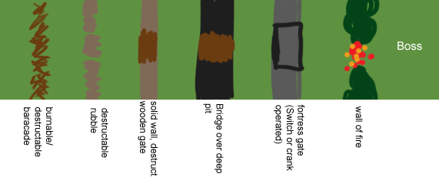

The assault map is a long vertical or horizontal map divided into sections by gated walls and barriers set up by rogue enemy NPC forces. The objective is for the players to work together and fight their way through each increasingly difficult section by clearing out enemy forces and finding the way to open the next gate or pass the next obstacle.

Early on, the gates may be made of sticks or weak material that you can burn or break down. As your team progresses, the way to pass gates becomes less and less straightforward, requiring you to find a switch or a key dropped from an enemy NPC, or put out a large wall of fire set up by enemy forces upon your arrival. Enemies also become smarter, come in waves to slow the progress, and some even stand on the baracade and attack from a safe distance.

Players have 50 minutes to reach the end of the map, where they will finally face the boss and his/her minions. If players can reach the end and defeat the boss, they've completed a successful Assault mission and are returned to the appropriate administration building and given a large reward.

Alternatively, if a player dies while in an Assault game, they respawn outside and cannot return until the next game. If all participating players die, the game ends and the players lose.

PVP Arena

The PVP arena is basically a battle arena in every hidden village where players can have friendly competition against each other. Other players can spectate matches and place bets on matches. Winners get a large range of rewards, +REP, Titles, and Achievements. During matches; players can put up valuable items up for grabs as loot.

Game Modes -
Capture the scroll
Team Death Match
Guardian
Singles
Annex

GM Control Panel [J01]

Special window for easily accessable GM commands. Includes such commands like ban (w/ option to specify length of ban), kick, jail, Announce (Changes message at top text bar), Mute, Go to ___, Bring ___ to and other typical adminitrative commands.

May also include an item generator for GM's with high permission, where custom items can be created manually, allowing the person to set stat bonuses and added effects, assign specific equipment/item type, choose icon, name, etc.

